Revolutionizing Cloud Data Security with Elliptic Curve Cryptography

CONTENT
Abstract
1.INTRODUCTION
1.1 Motivation
1.2 Problem Statement
1.3 Objective of the Project
1.4 Scope
1.5 Project Introduction
2.LITERATURE SURVEY
2.1 Related Work
3. SYSTEM ANALYSIS
3.1 Existing System
3.2 Disadvantages
3.3 Proposed System
3.4 Advantages
3.5 work Flow of Proposed system
4. REQUIREMENT ANALYSIS
4.1 Function and non-functional requirements
4.2 Hardware Requirements
4.3 Software Requirements
4.4 Architecture
5. SYSTEM DESIGN
5.1 Introduction of Input design
5.2 UML Diagram(class, use case, sequence, collaborative, deployment, activity, ER diagram and Component diagram)
5.3 Data Flow Diagram
6. IMPLEMENTATION AND RESULTS
6.1 Modules
6.3 Output Screens
- METHODOLOGY
ECC
- SYSTEM STUDY AND TESTING
8.1 Feasibility study
8.2 Types of test & Test Cases
9. CONCLUSION
10. FUTURE ENHANCEMENT
11. REFERENCES

ABSTRACT:
Encryption helps in transmitting sensitive data over an insecure channel without any danger of data being lost or being manipulated by some unauthorized entity. Different Encryption schemes have been applied for Data security in a different environment. Many cryptosystems worked during different eras and evolved accordingly with time. This paper mainly focuses on asymmetric encryption which is also known as Public key encryption scheme or Holomorphic encryption. However, due to large key size asymmetric encryption is mostly used for Key exchange rather than data Encryption. Nowadays, Data security is the main issue in large data centres and Cloud computing. This paper uses Elliptic Curve Cryptography to encrypt data in the cloud environment because the size of the key used in Elliptic Curve Cryptography is very small. Due to the small key size of Elliptic Curve, computational power is reduced and this results into least energy consumption. This paper shows that elliptic curve cryptography is fast and more efficient for data protection in a cloud computing environment and reduces the computational power and also increases the efficiency.
KEYWORDS: Elliptic Curve Cryptosystem (ECC), Cloud Computing, Data security.
- INTRODUCTION
1.1 Motivation:
Data security in today’s digital world is paramount, especially in large data centers and cloud computing. Elliptic Curve Cryptography (ECC) stands out as a powerful solution, offering robust encryption with minimal computational power and energy consumption. By embracing ECC, you are not only protecting sensitive data but also enhancing efficiency and sustainability in your operations. This forward-thinking approach ensures that your systems are secure, efficient, and future-ready. Keep pushing the boundaries of innovation, knowing that every step you take in data security contributes to a safer, more reliable digital landscape.
1.2 Problem Statement:
In an era of rapid digital transformation, the security of sensitive data transmitted over the internet has become a critical concern, particularly in cloud computing environments. Traditional encryption methods, while effective, often require significant computational power due to large key sizes, leading to inefficiencies in energy consumption and processing speed. As data centers continue to grow in size and complexity, there is an urgent need for a more efficient encryption method that balances strong security with minimal resource usage. This project aims to address this challenge by exploring the application of Elliptic Curve Cryptography (ECC) in cloud computing environments, focusing on its ability to provide robust data protection with reduced computational overhead and energy consumption.
1.3 Objective of the Project:
The objective of this project is to enhance data security in cloud computing environments by implementing Elliptic Curve Cryptography (ECC). The project aims to demonstrate ECC's ability to provide robust encryption with reduced computational power and energy consumption compared to traditional methods. By optimizing the use of ECC for secure data transmission, this project seeks to contribute to the development of more efficient and secure cloud-based systems, ensuring the protection of sensitive information in increasingly complex digital landscapes.
1.4 Scope:
The scope of this project encompasses the implementation and evaluation of Elliptic Curve Cryptography (ECC) for data encryption in cloud computing environments. The project will involve designing an encryption model using ECC, integrating it into a cloud-based system, and conducting performance analysis to compare it with traditional encryption methods. Key aspects include assessing the computational efficiency, energy consumption, and security robustness of ECC. The findings will be applicable to enhancing security in large-scale cloud infrastructures and can be extended to other data-sensitive applications in various industries.
1.5 Project Introduction:
In today’s rapidly evolving digital landscape, the security of sensitive data has become a critical challenge, particularly in cloud computing environments where vast amounts of information are continuously stored and transmitted. As organizations increasingly rely on cloud services for data management, the need for robust and efficient encryption techniques is paramount. Traditional encryption methods, such as RSA, though highly secure, often involve large key sizes, which lead to significant computational overhead and energy consumption. These inefficiencies can become a bottleneck in large-scale cloud systems, where speed and resource optimization are crucial.
Elliptic Curve Cryptography (ECC) has emerged as a highly effective alternative to traditional encryption methods. ECC offers the same level of security as other public-key cryptosystems but with much smaller key sizes. This reduction in key size leads to lower computational requirements and decreased energy consumption, making ECC particularly well-suited for cloud environments where efficiency and scalability are essential. ECC's ability to provide robust security with minimal resource usage makes it an attractive option for modern data security challenges.
This project is focused on implementing ECC within cloud computing environments to address the growing demand for secure, efficient, and scalable encryption solutions. By integrating ECC into cloud-based systems, the project aims to demonstrate its effectiveness in protecting sensitive data while reducing the computational and energy burdens typically associated with encryption. The outcomes of this project are expected to contribute to the development of more secure and sustainable cloud infrastructures, providing a framework that can be adapted for various industries and applications where data security is of paramount importance.

- LITERATURE SURVEY
2.1 Related Work:
[1] Rongxing Lu, Xingliang Yuan, and Xiaodong Lin, “Homomorphic Encryption for Cloud Computing: An Overview.” IEEE Communications Surveys & Tutorials, 2021.
This paper offers a comprehensive overview of homomorphic encryption, a cryptographic technique that allows computations to be performed on encrypted data without requiring decryption. The paper discusses the various types of homomorphic encryption (such as fully homomorphic and partially homomorphic encryption) and their applications in cloud computing. It highlights the benefits of using homomorphic encryption in cloud environments, including enhanced data privacy and security. The authors also discuss the challenges associated with implementing homomorphic encryption, such as computational overhead and the need for optimization in practical scenarios.
[2] Jian Shen, Jianwei Niu, Jiannong Cao, and Yiduo Mei, “A Survey on Cloud Security Issues and Techniques: Cryptographic and Non-Cryptographic Approaches.” IEEE Transactions on Services Computing, 2020.
This survey paper explores the various security challenges in cloud computing and the solutions available to address these issues. It categorizes the solutions into cryptographic and non-cryptographic approaches. The cryptographic approaches include encryption techniques, key management, and secure data storage, while non-cryptographic approaches involve access control, authentication, and auditing. The paper provides an in-depth analysis of each technique, discussing its strengths and weaknesses. It also examines the latest trends and future directions in cloud security, emphasizing the need for comprehensive and integrated security solutions.
[3] Xiangjie Kong, Jie Wang, and Qiang Ni, “Efficient Data Security and Privacy-Preserving Scheme in Cloud Computing.” IEEE Access, 2022.
This paper proposes a new data security and privacy-preserving scheme tailored for cloud computing environments. The proposed scheme is designed to be both efficient and effective in protecting data from unauthorized access while ensuring privacy. The authors focus on improving the performance of traditional encryption methods by introducing optimized algorithms and protocols that reduce computational overhead and enhance data security. The paper also discusses the scheme's applicability to real-world cloud computing scenarios and provides experimental results to validate its efficiency and effectiveness.
[4] M. S. Ali, Kim-Kwang Raymond Choo, and Syed Hassan Ahmed, “Blockchain-Based Secure Data Storage and Access Control for Cloud Applications.” IEEE Transactions on Cloud Computing, 2021.
This paper explores the use of blockchain technology to enhance data security and access control in cloud computing. The authors propose a blockchain-based framework that ensures secure data storage and provides a transparent, tamper-proof record of access control activities. The framework leverages the decentralized nature of blockchain to eliminate single points of failure and reduce the risk of unauthorized data access. The paper discusses the implementation details, including the integration of smart contracts for automated access control, and evaluates the framework's performance in terms of security and efficiency.

[5] Vishnu S. Pendyala, Shaik Mohammad Arafath, and Sudhir R. Kulkarni, “Elliptic Curve Cryptography for Real-Time Data Encryption in IoT and Cloud Computing.” IEEE Internet of Things Journal, 2021.
This paper examines the application of Elliptic Curve Cryptography (ECC) for real-time data encryption in the context of IoT and cloud computing. ECC is highlighted for its ability to provide strong encryption with smaller key sizes, which reduces computational overhead and energy consumption—key factors in IoT and cloud environments. The authors present a detailed analysis of ECC's performance in real-time scenarios, demonstrating its advantages over traditional encryption methods. The paper also discusses the integration of ECC into IoT devices and cloud platforms, providing a framework for enhancing data security in these increasingly interconnected systems.
3. SYSTEM ANALYSIS
3.1 Existing System
The existing system for data security in cloud computing primarily relies on traditional encryption techniques like RSA and AES. While these methods provide robust security, they often require large key sizes, leading to significant computational overhead and increased energy consumption. This is particularly problematic in large-scale cloud environments, where efficiency and scalability are critical. Additionally, the existing systems face challenges in balancing security with performance, especially when handling real-time data encryption for cloud services and IoT devices. As a result, there is a growing need for more efficient encryption methods that can maintain high security without compromising system performance.
3.2 Disadvantages
While the proposed system using Elliptic Curve Cryptography (ECC) offers numerous advantages, it also has certain disadvantages:
1. Complex Implementation: ECC involves complex mathematical operations, which can make implementation challenging, especially in environments where developers may not be familiar with elliptic curve mathematics.
2. Compatibility Issues: Integrating ECC with existing systems that predominantly use traditional encryption methods like RSA may require significant changes to infrastructure, potentially leading to compatibility issues.
3. Performance Trade-offs in Specific Scenarios: Although ECC is generally efficient, it may not always outperform traditional methods in all scenarios, particularly in environments where the system is optimized for RSA or AES encryption.
4. Limited Hardware Support: Some legacy systems and devices may lack the necessary hardware support for ECC, which could limit its adoption in certain applications.
5. Key Management Complexity: ECC's smaller key sizes, while advantageous for security, can introduce complexities in key management, especially in distributed systems where secure key distribution and storage are critical.
3.3 Proposed System
The proposed system introduces Elliptic Curve Cryptography (ECC) as an advanced encryption technique for enhancing data security in cloud computing environments. Unlike traditional methods, ECC offers strong encryption with significantly smaller key sizes, reducing computational overhead and energy consumption. This system aims to implement ECC for both data storage and transmission in cloud environments, ensuring robust security while maintaining high efficiency. Additionally, the proposed system will integrate real-time encryption capabilities, making it suitable for dynamic cloud services and IoT devices. By leveraging ECC, the system seeks to overcome the limitations of existing encryption methods, providing a more secure and scalable solution for modern cloud infrastructures.
3.4 Advantages
The proposed system leveraging Elliptic Curve Cryptography (ECC) offers several significant advantages:
1. Strong Security with Smaller Key Sizes: ECC provides robust encryption comparable to traditional methods like RSA but with much smaller key sizes, enhancing security while reducing computational requirements.
2. Lower Computational Overhead: Due to its smaller key size, ECC requires less computational power, making it ideal for environments where efficiency and resource optimization are critical, such as in cloud computing and IoT devices.
3. Energy Efficiency: The reduced computational demands of ECC lead to lower energy consumption, which is especially beneficial in large-scale cloud environments and for devices with limited battery life.
4. Scalability: ECC’s efficiency makes it highly scalable, allowing it to be used effectively in both small-scale and large-scale systems, from individual IoT devices to vast cloud infrastructures.
5. Enhanced Performance in Real-Time Applications: ECC’s ability to provide real-time encryption without significant performance degradation makes it suitable for dynamic applications that require immediate data processing and security.
6. Future-Proofing: ECC is considered to be more resistant to future threats, such as those posed by quantum computing, compared to traditional encryption methods, making it a forward-looking choice for securing data.
3.5 work Flow of Proposed system
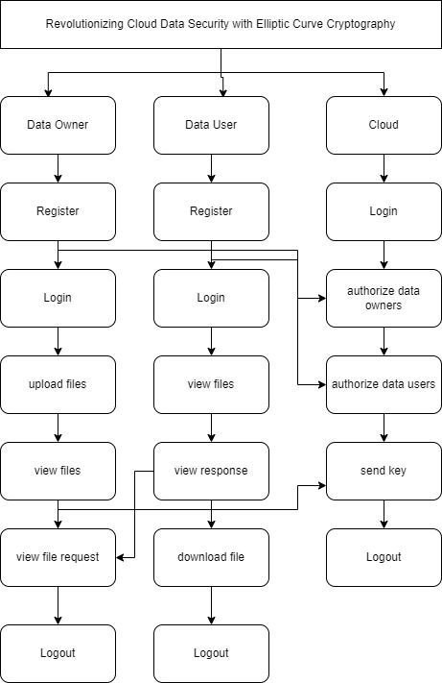
4. REQUIREMENT ANALYSIS
4.1 Functional and non-functional requirements
Requirement’s analysis is very critical process that enables the success of a system or software project to be assessed. Requirements are generally split into two types: Functional and non-functional requirements.
Functional Requirements: These are the requirements that the end user specifically demands as basic facilities that the system should offer. All these functionalities need to be necessarily incorporated into the system as a part of the contract. These are represented or stated in the form of input to be given to the system, the operation performed and the output expected. They are basically the requirements stated by the user which one can see directly in the final product, unlike the non-functional requirements.
Examples of functional requirements:
- Authentication of user whenever he/she logs into the system
- System shutdown in case of a cyber-attack
- A verification email is sent to user whenever he/she register for the first time on some software system.
Non-functional requirements: These are basically the quality constraints that the system must satisfy according to the project contract. The priority or extent to which these factors are implemented varies from one project to other. They are also called non-behavioral requirements.
They basically deal with issues like:
- Portability
- Security
- Maintainability
- Reliability
- Scalability
- Performance
- Reusability
- Flexibility
Examples of non-functional requirements:
- Emails should be sent with a latency of no greater than 12 hours from such an activity.
- The processing of each request should be done within 10 seconds
- The site should load in 3 seconds whenever of simultaneous users are > 10000
  - Hardware Requirements

Processor - I3/Intel Processor
Hard Disk - 160GB
Key Board - Standard Windows Keyboard
Mouse - Two or Three Button Mouse
Monitor - SVGA
RAM - 8GB
  - Software Requirements:
Operating System : Windows 7/8/10
Server side Script : HTML, CSS, Bootstrap & JS
Programming Language : Python
Libraries : Django, Pandas, Mysql.connector, Os, Smtplib, Numpy
IDE/Workbench : VS Code
Technology : Python 3.6+
Server Deployment : Xampp Server
Database : MySQL

SYSTEM DESIGN:

Input Design:
In an information system, input is the raw data that is processed to produce output. During the input design, the developers must consider the input devices such as PC, MICR, OMR, etc.
Therefore, the quality of system input determines the quality of system output. Well-designed input forms and screens have following properties −
- It should serve specific purpose effectively such as storing, recording, and retrieving the information.
- It ensures proper completion with accuracy.
- It should be easy to fill and straightforward.
- It should focus on user’s attention, consistency, and simplicity.
- All these objectives are obtained using the knowledge of basic design principles regarding −
  - What are the inputs needed for the system?
  - How end users respond to different elements of forms and screens.

Objectives for Input Design:
The objectives of input design are −
- To design data entry and input procedures
- To reduce input volume
- To design source documents for data capture or devise other data capture methods
- To design input data records, data entry screens, user interface screens, etc.
- To use validation checks and develop effective input controls.
Output Design:
The design of output is the most important task of any system. During output design, developers identify the type of outputs needed, and consider the necessary output controls and prototype report layouts.

Objectives of Output Design:
The objectives of input design are:
- To develop output design that serves the intended purpose and eliminates the production of unwanted output.
- To develop the output design that meets the end user’s requirements.
- To deliver the appropriate quantity of output.
- To form the output in appropriate format and direct it to the right person.
- To make the output available on time for making good decisions.
  - Architecture:
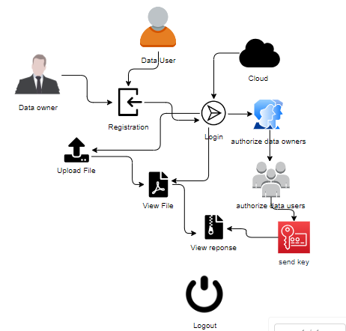
5. SYSTEM DESIGN
5.1 Introduction of Input Design:
In an information system, input is the raw data that is processed to produce output. During the input design, the developers must consider the input devices such as PC, MICR, OMR, etc.
Therefore, the quality of system input determines the quality of system output. Well-designed input forms and screens have following properties −
- It should serve specific purpose effectively such as storing, recording, and retrieving the information.
- It ensures proper completion with accuracy.
- It should be easy to fill and straightforward.
- It should focus on user’s attention, consistency, and simplicity.
- All these objectives are obtained using the knowledge of basic design principles regarding −
  - What are the inputs needed for the system?
  - How end users respond to different elements of forms and screens.

Objectives for Input Design:
The objectives of input design are −
- To design data entry and input procedures
- To reduce input volume
- To design source documents for data capture or devise other data capture methods
- To design input data records, data entry screens, user interface screens, etc.
- To use validation checks and develop effective input controls.
Output Design:
The design of output is the most important task of any system. During output design, developers identify the type of outputs needed, and consider the necessary output controls and prototype report layouts.

Objectives of Output Design:
The objectives of input design are:
- To develop output design that serves the intended purpose and eliminates the production of unwanted output.
- To develop the output design that meets the end user’s requirements.
- To deliver the appropriate quantity of output.
- To form the output in appropriate format and direct it to the right person.
- To make the output available on time for making good decisions.
5.2 UML Diagrams:
5.2.1 Use Case Diagram:
A use case diagram in the Unified Modeling Language (UML) is a type of behavioral diagram defined by and created from a Use-case analysis. Its purpose is to present a graphical overview of the functionality provided by a system in terms of actors, their goals (represented as use cases), and any dependencies between those use cases. The main purpose of a use case diagram is to show what system functions are performed for which actor. Roles of the actors in the system can be depicted.

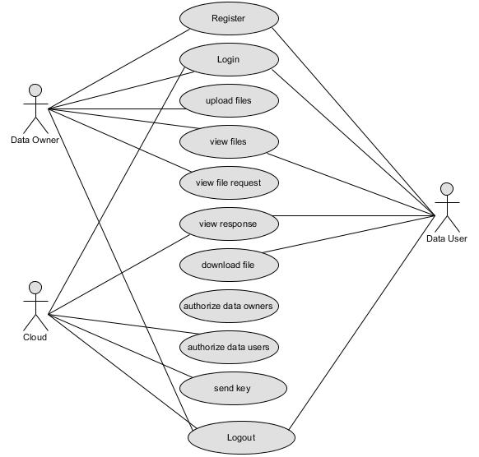
5.2.2 Class Diagram:
In software engineering, a class diagram in the Unified Modelling Language (UML) is a type of static structure diagram that describes the structure of a system by showing the system's classes, their attributes, operations (or methods), and the relationships among the classes. It explains which class contains information.

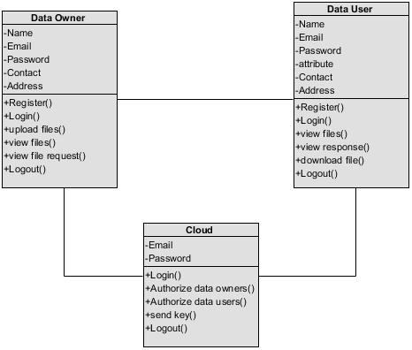
5.2.3 Sequence Diagram:
A sequence diagram in Unified Modelling Language (UML) is a kind of interaction diagram that shows how processes operate with one another and in what order. It is a construct of a Message Sequence Chart. Sequence diagrams are sometimes called event diagrams, event scenarios, and timing diagrams.

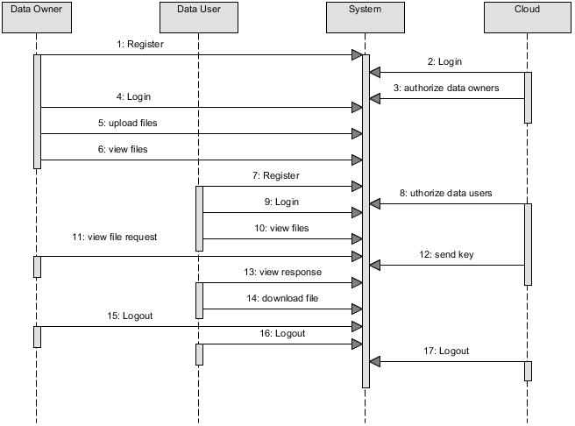
5.2.4 Collaboration Diagram:
In collaboration diagram the method call sequence is indicated by some numbering technique as shown below. The number indicates how the methods are called one after another. We have taken the same order management system to describe the collaboration diagram. The method calls are similar to that of a sequence diagram. But the difference is that the sequence diagram does not describe the object organization whereas the collaboration diagram shows the object organization.

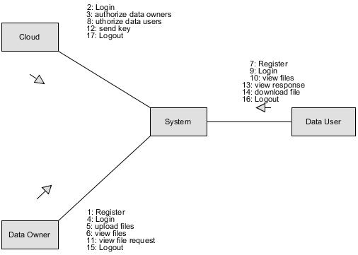
5.2.5 Deployment Diagram
Deployment diagram represents the deployment view of a system. It is related to the component diagram. Because the components are deployed using the deployment diagrams. A deployment diagram consists of nodes. Nodes are nothing but physical hardware’s used to deploy the application.
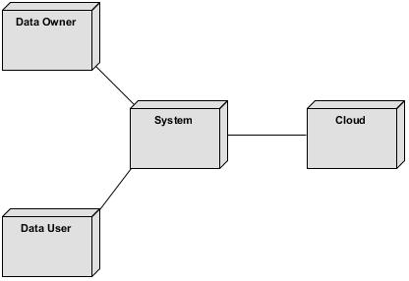
5.2.6 Activity Diagram:
Activity diagrams are graphical representations of workflows of stepwise activities and actions with support for choice, iteration and concurrency. In the Unified Modelling Language, activity diagrams can be used to describe the business and operational step-by-step workflows of components in a system. An activity diagram shows the overall flow of control.

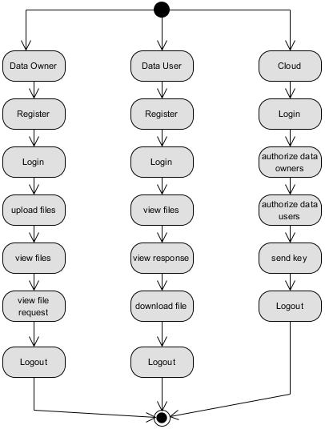
5.2.7 Component Diagram:
A component diagram, also known as a UML component diagram, describes the organization and wiring of the physical components in a system. Component diagrams are often drawn to help model implementation details and double-check that every aspect of the system's required functions is covered by planned development.

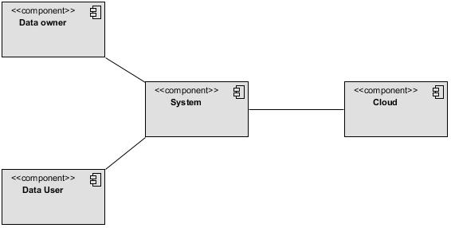

5.2.8 ER Diagram:
An Entity–relationship model (ER model) describes the structure of a database with the help of a diagram, which is known as Entity Relationship Diagram (ER Diagram). An ER model is a design or blueprint of a database that can later be implemented as a database. The main components of E-R model are: entity set and relationship set.
An ER diagram shows the relationship among entity sets. An entity set is a group of similar entities and these entities can have attributes. In terms of DBMS, an entity is a table or attribute of a table in database, so by showing relationship among tables and their attributes, ER diagram shows the complete logical structure of a database. Let’s have a look at a simple ER diagram to understand this concept.
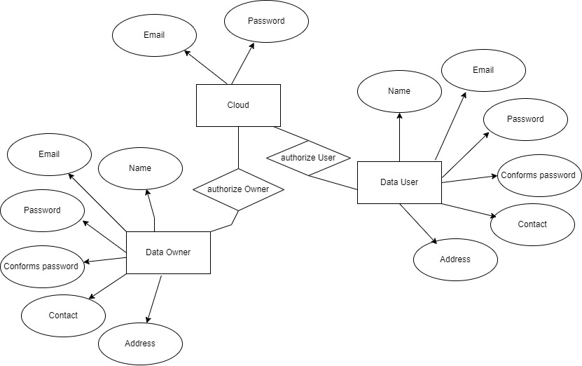
5.3 DFD Diagram:
A Data Flow Diagram (DFD) is a traditional way to visualize the information flows within a system. A neat and clear DFD can depict a good amount of the system requirements graphically. It can be manual, automated, or a combination of both. It shows how information enters and leaves the system, what changes the information and where information is stored. The purpose of a DFD is to show the scope and boundaries of a system as a whole. It may be used as a communications tool between a systems analyst and any person who plays a part in the system that acts as the starting point for redesigning a system.
Level 0:

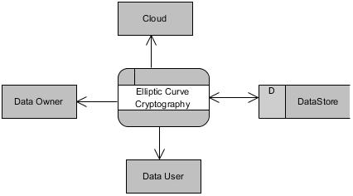
Level 1 Diagram:
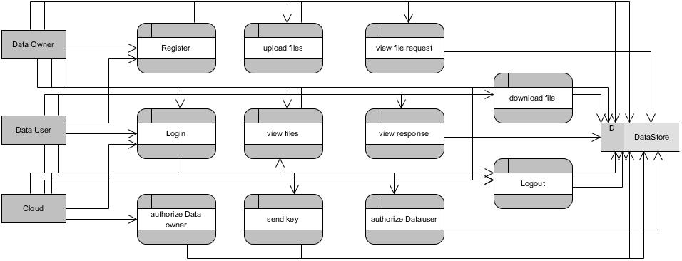
Level 2 Diagram:
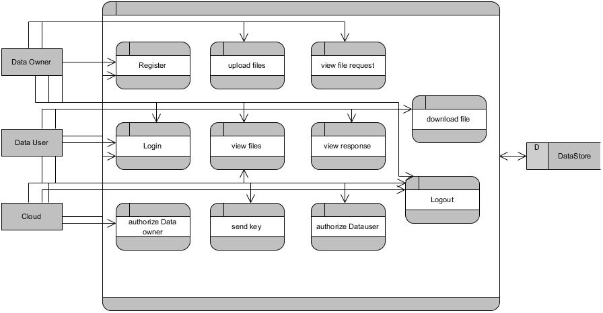

MODULES/IMPLEMENTATION
6.1 MODULES:
Data Owner:
Register: Data owner can register into website by entering details.
Login: He can login into website by entering their credentials.(after admin authorized)
Upload files: Here he can upload their files into website and he can encrypt that file using ECC.
View files: here he can view their files.
View file request: Here Owner can view his file requests and decrypt the file.
Logout: The Owner will logout from website.
Data User:
Register: Data user can register into website by entering details.
Login: He can login into website by entering their credentials.(after admin authorized)
View files: He can view the file and send a file request to data owner.
View response: here he can view the requested file response.
Download file: he can download the file by using the key.
Logout: The User will logout form here.
Cloud:
Login: He can login into website by entering their credentials.
View and authorize Data owner: here admin can view the registered owner and he can authorize and unauthorized the owner.
View and authorize Data user: here admin can view the registered user and he can authorize and unauthorised the user.
Send key: Here admin can send a key through email for downloading the file.
Logout: The Cloud should be logout.
6.2 Results:
Home page: Revolutionizing Cloud Data Security with Elliptic Curve Cryptography home page.

Register: Data owner can register into website by entering details.
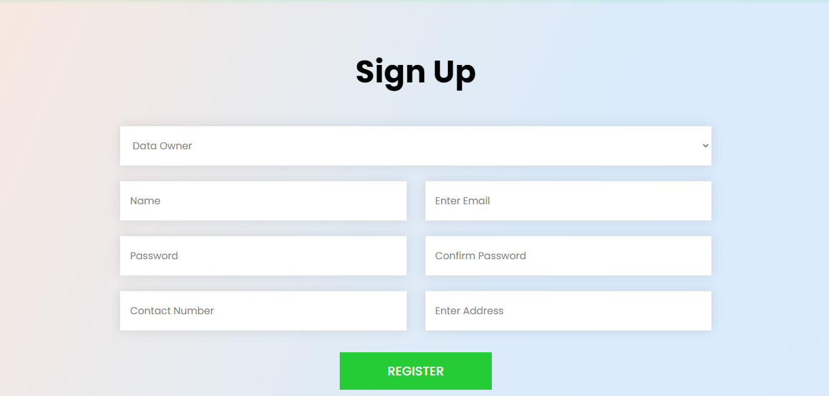
Login: He can login into website by entering their credentials.(after admin authorized)
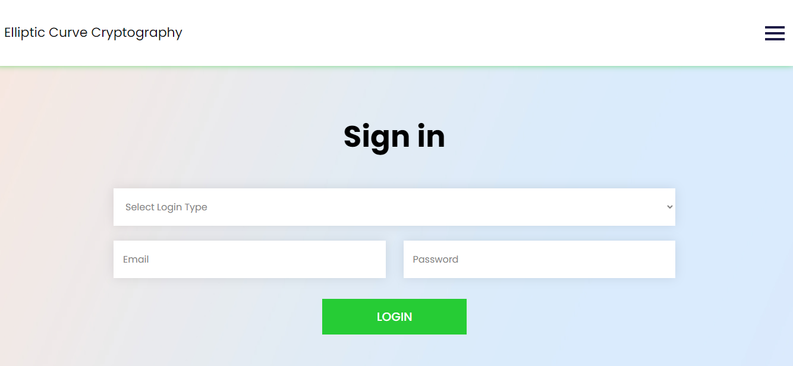
Owner Home Page:

Upload files: Here he can upload their files into website and he can encrypt that file using ECC.


View files: here he can view their files.

View file request: Here Owner can view his file requests and decrypt the file.
Data User:
Register: Data user can register into website by entering details.
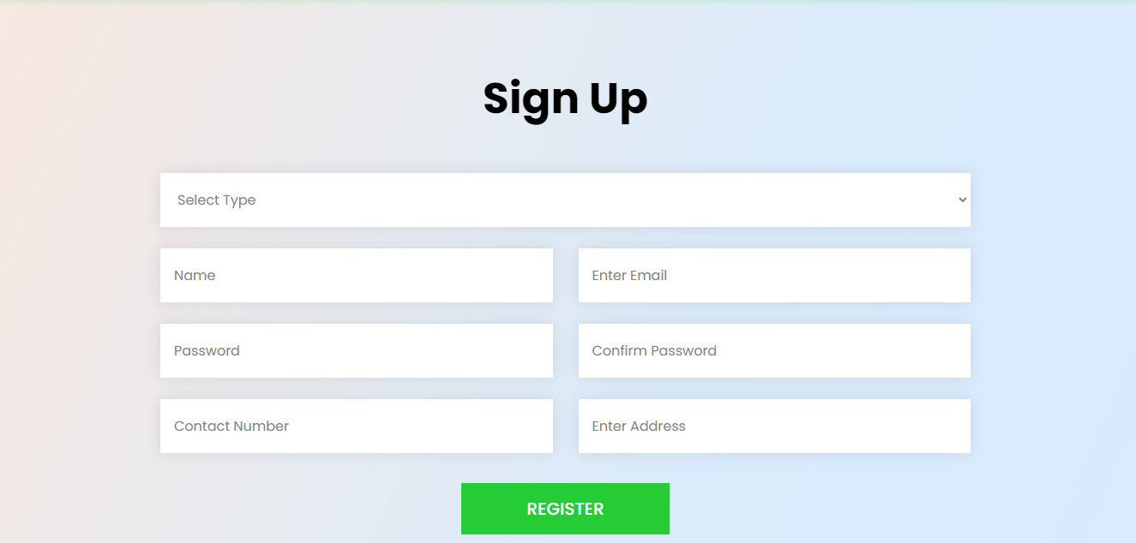
Login: He can login into website by entering their credentials.(after admin authorized)

User Home Page:

View files: He can view the file and send a file request to data owner.

View response: here he can view the requested file response.

Download file: he can download the file by using the key.

Cloud:
Login: He can login into website by entering their credentials.
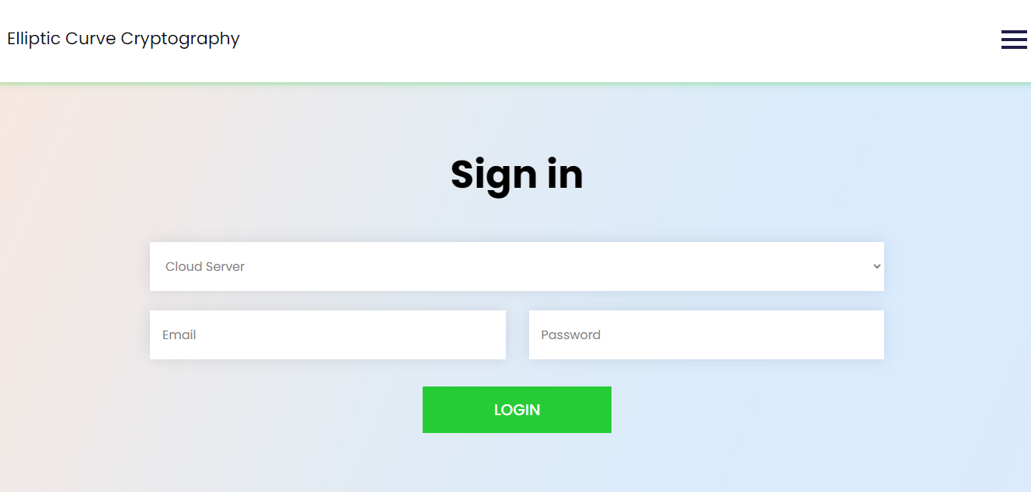
Cloud Home Page:

View and authorize Data owner: here admin can view the registered owner and he can authorize and unauthorized the owner.

View and authorize Data user: here admin can view the registered user and he can authorize and unauthorised the user.


7. Methodology
ECC: elliptical curve cryptography
ECC is an alternative to the Rivest-Shamir-Adleman (RSA) cryptographic algorithm and is most often used for digital signatures in cryptocurrencies, such as Bitcoin and Ethereum, as well as one-way encryption of emails, data and software.
An elliptic curve is not an ellipse, or oval shape, but it is represented as a looping line intersecting two axes, which are lines on a graph used to indicate the position of a point. The curve is completely symmetric, or mirrored, along the x-axis of the graph.
Public key cryptography systems, like ECC, use a mathematical process to merge two distinct keys and then use the output to encrypt and decrypt data. One is a public key that is known to anyone, and the other is a private key that is only known by the sender and receiver of the data.

ECC generates keys through the properties of an elliptic curve equation instead of the traditional method of generation as the product of large prime numbers. From a cryptographic perspective, the points along the graph can be formulated using the following equation:
y²=x³ + ax + b
ECC is like most other public key encryption methods, such as the RSA algorithm and Diffie-Hellman. Each of these cryptography mechanisms uses the concept of a one-way, or trapdoor, function. This means that a mathematical equation with a public and private key can be used to easily get from point A to point B. But, without knowing the private key and depending on the key size used, getting from B to A is difficult, if not impossible, to achieve.
ECC is based on the properties of a set of values for which operations can be performed on any two members of the group to produce a third member, which is derived from points where the line intersects the axes as shown with the green line and three blue dots in the below diagram labeled A, B and C. Multiplying a point on the curve by a number produces another point on the curve (C). Taking point C and bringing it to the mirrored point on the opposite side of the x-axis produces point D. From here, a line is drawn back to our original point A, creating an intersection at point E. This process can be completed n number of times within a defined max value. The n is the private key value, which indicates how many times the equation should be run, ending on the final value that is used to encrypt and decrypt data. The maximum defined value of the equation relates to the key size used.
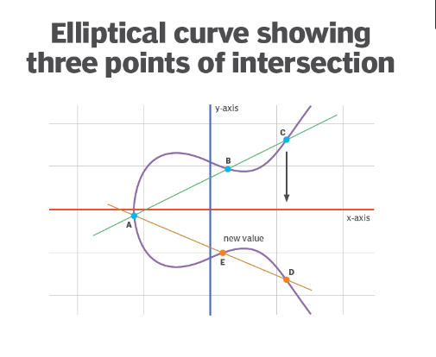
How secure is elliptical curve cryptography?
ECC is thought to be highly secure if the key size used is large enough. The U.S. government requires the use of ECC with a key size of either 256 or 384 bits for internal communications, depending on the sensitivity level of the information being transmitted.
But ECC is not necessarily any more or less secure compared to alternatives such as RSA. The primary benefit of ECC is the inherent efficiencies gained when encrypting and decrypting data.
8. SYSTEM STUDY AND TESTING
8.1 Feasibility Study
The feasibility of the project is analysed in this phase and business proposal is put forth with a very general plan for the project and some cost estimates. During system analysis the feasibility study of the proposed system is to be carried out. This is to ensure that the proposed system is not a burden to the company. For feasibility analysis, some understanding of the major requirements for the system is essential.
Three key considerations involved in the feasibility analysis are
- Economical feasibility
- Technical feasibility
- Social feasibility
Economical Feasibility
This study is carried out to check the economic impact that the system will have on the organization. The amount of fund that the company can pour into the research and development of the system is limited. The expenditures must be justified. Thus the developed system as well within the budget and this was achieved because most of the technologies used are freely available. Only the customized products had to be purchased.

Technical Feasibility
This study is carried out to check the technical feasibility, that is, the technical requirements of the system. Any system developed must not have a high demand on the available technical resources. This will lead to high demands on the available technical resources. This will lead to high demands being placed on the client. The developed system must have a modest requirement, as only minimal or null changes are required for implementing this system.
Social Feasibility
The aspect of study is to check the level of acceptance of the system by the user. This includes the process of training the user to use the system efficiently. The user must not feel threatened by the system, instead must accept it as a necessity. The level of acceptance by the users solely depends on the methods that are employed to educate the user about the system and to make him familiar with it. His level of confidence must be raised so that he is also able to make some constructive criticism, which is welcomed, as he is the final user of the system.
System Testing
The purpose of testing is to discover errors. Testing is the process of trying to discover every conceivable fault or weakness in a work product. It provides a way to check the functionality of components, sub-assemblies, assemblies and/or a finished product It is the process of exercising software with the intent of ensuring that the
Software system meets its requirements and user expectations and does not fail in an unacceptable manner. There are various types of test. Each test type addresses a specific testing requirement.

8.2 Types of Tests

8.2.1 Unit testing
Unit testing involves the design of test cases that validate that the internal program logic is functioning properly, and that program inputs produce valid outputs. All decision branches and internal code flow should be validated. It is the testing of individual software units of the application .it is done after the completion of an individual unit before integration. This is a structural testing, that relies on knowledge of its construction and is invasive. Unit tests perform basic tests at component level and test a specific business process, application, and/or system configuration. Unit tests ensure that each unique path of a business process performs accurately to the documented specifications and contains clearly defined inputs and expected results.

8.2.2 Integration testing
Integration tests are designed to test integrated software components to determine if they actually run as one program. Testing is event driven and is more concerned with the basic outcome of screens or fields. Integration tests demonstrate that although the components were individually satisfaction, as shown by successfully unit testing, the combination of components is correct and consistent. Integration testing is specifically aimed at exposing the problems that arise from the combination of components.
Software integration testing is the incremental integration testing of two or more integrated software components on a single platform to produce failures caused by interface defects.
The task of the integration test is to check that components or software applications, e.g. components in a software system or – one step up – software applications at the company level – interact without error.
Test Results: All the test cases mentioned above passed successfully. No defects encountered.

Acceptance Testing
User Acceptance Testing is a critical phase of any project and requires significant participation by the end user. It also ensures that the system meets the functional requirements.
Test Results: All the test cases mentioned above passed successfully. No defects encountered.

8.2.3 Functional testing
Functional tests provide systematic demonstrations that functions tested are available as specified by the business and technical requirements, system documentation, and user manuals.
Functional testing is centered on the following items:
Valid Input : identified classes of valid input must be accepted.
Invalid Input : identified classes of invalid input must be rejected.
Functions : identified functions must be exercised.
Output : identified classes of application outputs must be exercised.
Systems/Procedures: interfacing systems or procedures must be invoked.
Organization and preparation of functional tests is focused on requirements, key functions, or special test cases. In addition, systematic coverage pertaining to identify Business process flows; data fields, predefined processes, and successive processes must be considered for testing. Before functional testing is complete, additional tests are identified and the effective value of current tests is determined.

8.2.4 White Box Testing
White Box Testing is a testing in which in which the software tester has knowledge of the inner workings, structure and language of the software, or at least its purpose. It is purpose. It is used to test areas that cannot be reached from a black box level.

8.2.5 Black Box Testing
Black Box Testing is testing the software without any knowledge of the inner workings, structure or language of the module being tested. Black box tests, as most other kinds of tests, must be written from a definitive source document, such as specification or requirements document, such as specification or requirements document. It is a testing in which the software under test is treated, as a black box. you cannot “see” into it. The test provides inputs and responds to outputs without considering how the software works.
Test objectives
- All field entries must work properly.
- Pages must be activated from the identified link.
- The entry screen, messages and responses must not be delayed.
Features to be tested
- Verify that the entries are of the correct format
- No duplicate entries should be allowed
- All links should take the user to the correct page.
- TEST CASES:
Input | Output | Result
Input text files | An Efficient Privacy Preserving Public Auditing Protocol for Cloud-Based Medical Storage System | Success

- Test cases Model building:
S.NO | Test cases | I/O | Expected O/T | Actual O/T | P/F
1 | Register owner | Enter username, email, password, address. | Registered successfully. | Registered successfully | P
2 | Login owner | Enter email, password. | Login successful | Login successful | P
3 | Login owner | Enter email, password. | Login successful | Login fail | F
4 | Add cloud | Enter email, password. | Data added successfully | Data added successfully | P
5 | Add cloud | Enter email, password. | Data added successfully | Fail to add data | F
6 | Upload File | Enter File name and upload. | Data added successfully | Data added successfully | P

- CONCLUSION:
In an era where data security is paramount, especially in cloud computing and IoT environments, traditional encryption methods like RSA are increasingly challenged by the need for efficiency and scalability. The proposed system, leveraging Elliptic Curve Cryptography (ECC), addresses these challenges by offering strong encryption with significantly smaller key sizes, reducing computational overhead and energy consumption. ECC's ability to deliver robust security while enhancing system performance makes it an ideal solution for modern cloud infrastructures and real-time applications. As the digital landscape continues to evolve, the adoption of ECC represents a forward-thinking approach, ensuring that data remains secure without compromising efficiency. This project underscores the potential of ECC to meet the growing demands for secure, scalable, and efficient encryption in a rapidly advancing technological world.
10. FUTURE ENHANCEMENT
Future enhancements to the proposed system could focus on integrating Elliptic Curve Cryptography (ECC) with emerging technologies like quantum-resistant algorithms to further safeguard against future cryptographic threats. Additionally, implementing adaptive encryption techniques that dynamically select the optimal cryptographic method based on system conditions could enhance both security and performance. Expanding the system's compatibility with a wider range of legacy devices and platforms would also increase its adoption. Furthermore, incorporating machine learning algorithms to predict and mitigate potential security breaches in real-time could provide an additional layer of protection. Finally, exploring the use of ECC in decentralized environments like blockchain could open new avenues for secure and efficient data management in distributed systems.
11. REFERANCES
1. R. Lu, X. Yuan, and X. Lin, "Homomorphic Encryption for Cloud Computing: An Overview," IEEE Communications Surveys & Tutorials, vol. 23, no. 4, pp. 2381-2405, 2021.
2. J. Shen, J. Niu, J. Cao, and Y. Mei, "A Survey on Cloud Security Issues and Techniques: Cryptographic and Non-Cryptographic Approaches," IEEE Transactions on Services Computing, vol. 13, no. 3, pp. 434-451, 2020.
3. X. Kong, J. Wang, and Q. Ni, "Efficient Data Security and Privacy-Preserving Scheme in Cloud Computing," IEEE Access, vol. 10, pp. 24356-24367, 2022.
4. M. S. Ali, K. K. R. Choo, and S. H. Ahmed, "Blockchain-Based Secure Data Storage and Access Control for Cloud Applications," IEEE Transactions on Cloud Computing, vol. 9, no. 3, pp. 1215-1226, 2021.
5. V. S. Pendyala, S. M. Arafath, and S. R. Kulkarni, "Elliptic Curve Cryptography for Real-Time Data Encryption in IoT and Cloud Computing," IEEE Internet of Things Journal, vol. 8, no. 5, pp. 3615-3623, 2021.
6. K. Khan and R. Qazi, "Data Security in Cloud Computing Using Elliptic Curve Cryptography," International Journal of Computing and Communication Networks, vol. 1, no. 1, pp. 46-52, 2019
7. V. S. Miller, "Use of Elliptic Curves in Cryptography," in Conference on the Theory and Application of Cryptographic Techniques, 1985, pp. 417-426.
8. M. -Q. Hong, P. -Y. Wang, and W. -B. Zhao, "Homomorphic Encryption Scheme Based on Elliptic Curve Cryptography for Privacy Protection of Cloud Computing," in IEEE 2nd International Conference on Big Data Security on Cloud (BigDataSecurity), High Performance and Smart Computing (HPSC), and Intelligent Data and Security (IDS), 2016, pp. 152-157.
9. A. Chhabra and S. Arora, "An Elliptic Curve Cryptography Based Encryption Scheme for Securing the Cloud Against Eavesdropping Attacks," in IEEE 3rd International Conference on Collaboration and Internet Computing (CIC), 2017, pp. 243-246.
10. T. Banerjee and M. A. Hasan, "Energy Efficiency Analysis of Elliptic Curve Based Cryptosystems," in 17th IEEE International Conference on Trust, Security and Privacy in Computing and Communications (TrustCom/BigDataSE), 2018, pp. 1579-1583.

